**DAILY ONLINE ACTIVITIES SUMMARY**

|  |  |  |  |  |  |  |  |
| --- | --- | --- | --- | --- | --- | --- | --- |
| **Date:** | 01-06-2020 | | | | **Name:** | Gudugunti Anirudh | |
| **Sem & Sec** | IV - A | | | | **USN:** | 4AL18CS023 | |
| **Online Test Summary** | | | | | | | |
| **Subject** | | | Complex analysis, probability and statistical methods | | --- | | | | | | |
| **Max. Marks** | | 30 | | **Score** | | 30 | |
| **Certification Course Summary** | | | | | | | |
| **Course** | Python in ML | | | | | | |
| **Certificate Provider** | | | Greatlearning.in | **Duration** | | | **2hrs** |
| **Coding Challenges** | | | | | | | |
| **Problem Statement:** 1. Calculating nPr value  2. Finding subarrays of an array based on certain condition | | | | | | | |
| **Status:** completed | | | | | | | |
| **Uploaded the report in Github** | | | | yes | | | |
| **If yes Repository name** | | | | https://github.com/alvas-education-foundation/anirudh_gudugunti/tree/master/daily_progress | | | |
| **Uploaded the report in slack** | | | | yes | | | |

**Online Test Details:**

The online test was from module 5 which was about joint probability distribution and sampling theory. There were 20 questions where 10 was for 1 mark each and the remaining 10 for 2 marks each and the duration was 45 minutes. The questions were optimal and were easy. The score that I got in the test is 30/30.

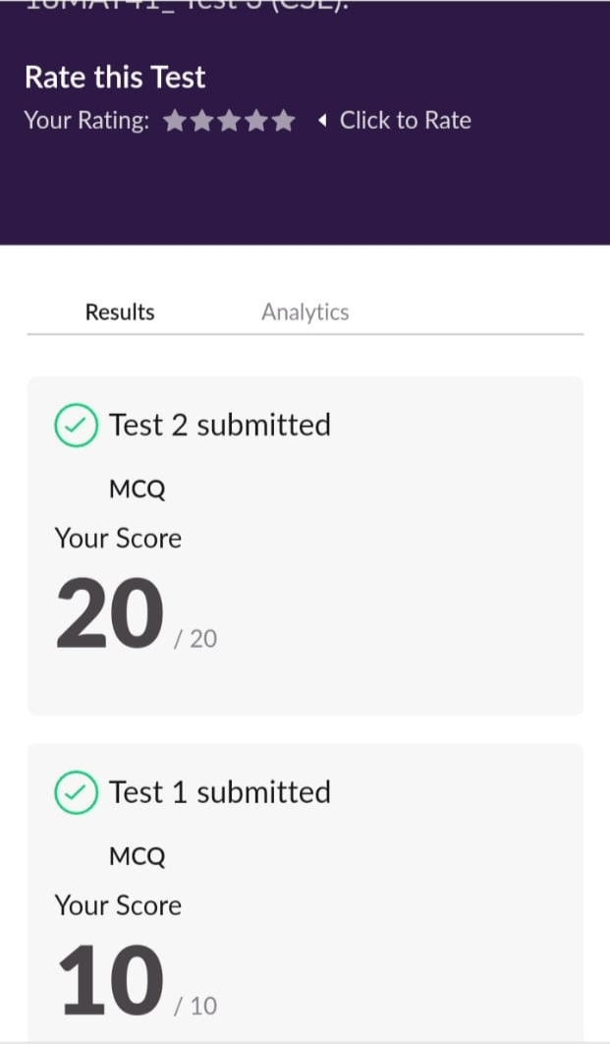

Certification course details:

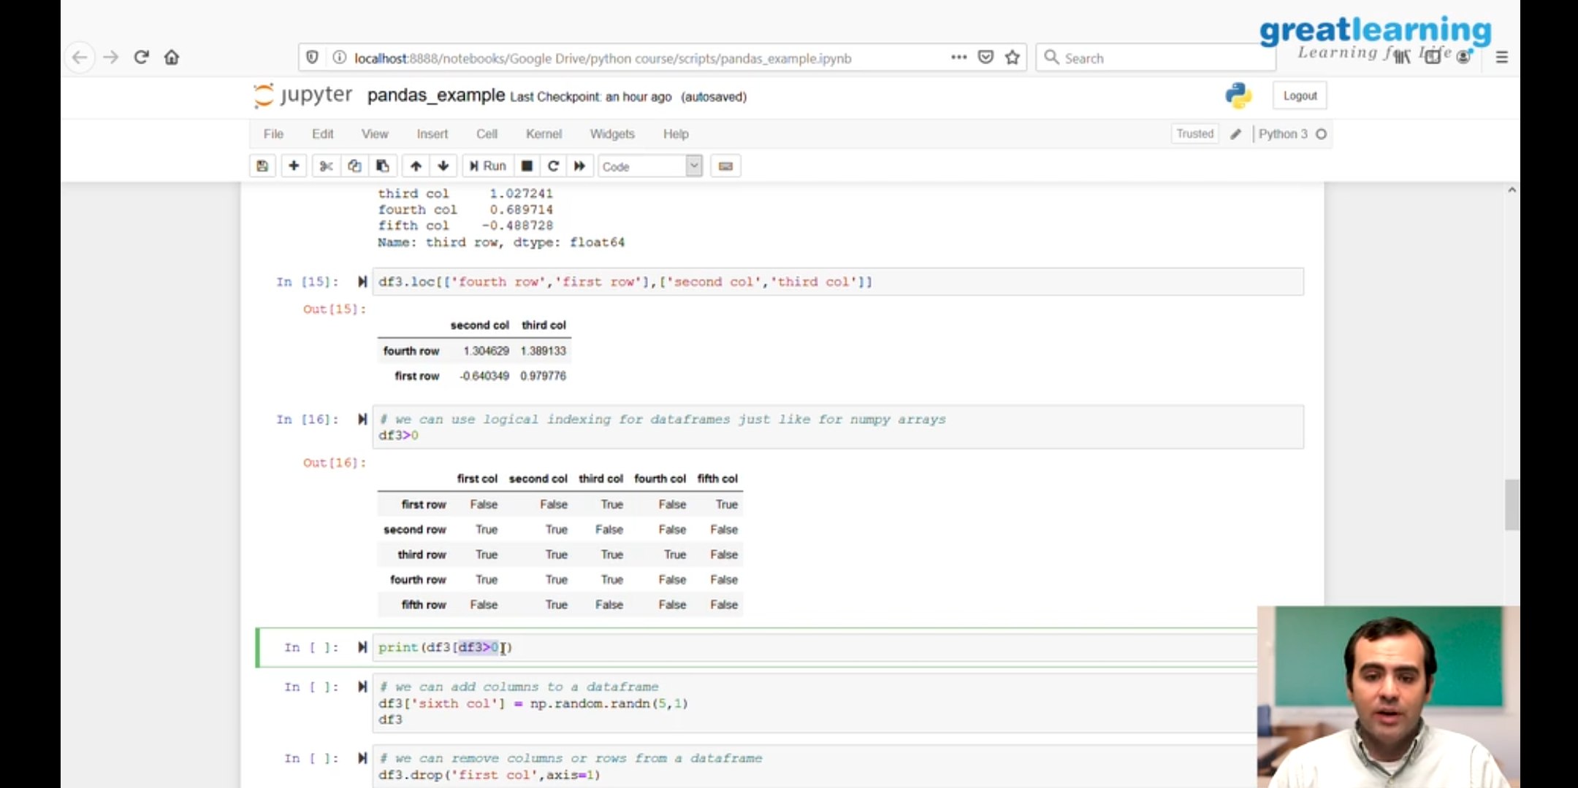

1. Detailed instructions on series and data frames in python .

2 .How to access data frames.

3.How to modify data frames.

Online coding details:

Problem 1: (using JAVA) Write a Java program to calculate nPr.

